Game Design Document

Fill up the following document

1. Write the title of your project.

Mission to save Earth

1. What is the goal of the game?

The goal of game is to enhance player’s shooting skills and to encourage the player to save our home planet.

1. Write a brief story of your game.

There is a fighter named Sam and he is in a space shuttle to shoot off

the asteroids , in order to protect the Earth.

1. Which are the playing characters of this game?

* Playing characters are the ones who respond to the user based on the input from the user.
* Cars, monkeys, dinos, wizards, etc., are the playing characters in the game.

|  |  |  |
| --- | --- | --- |
| Number | Character Name | What can this character do? |
| 1 | Sam | It can be controlled by the user and it can shoot off the enemies. |
| 2 |  |  |
| 3 |  |  |
| 4 |  |  |
| 5 |  |  |
| 6 |  |  |
| 7 |  |  |
| 8 |  |  |

1. Which are the Non-Playing Characters of this game?

* Non-Playing characters are the ones that don't have an action or behavior when the user interacts with the game.
* Hurdles, stones, bananas, coins, etc., are non-playing characters in the game.

|  |  |  |
| --- | --- | --- |
| Number | Character Name | What can this character do? |
| 1 | Asteroids | It is the enemy that need to be destroyed |
| 2 | Earth | It is the character that needs to be protected by the asteroids. |
| 3 |  |  |
| 4 |  |  |
| 5 |  |  |
| 6 |  |  |
| 7 |  |  |
| 8 |  |  |

Draw your imagination of this game. What does this game look like?

* Draw the game either on your computer or on paper.
* Add images of the game scenes to show each of the playing and non-playing characters at least once.

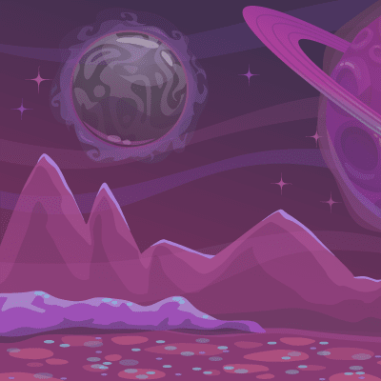

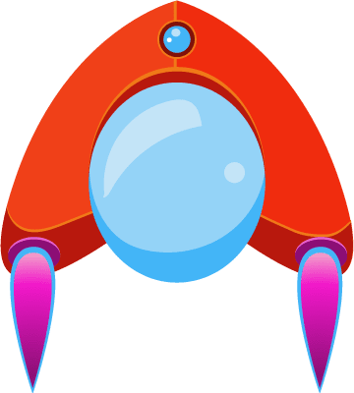



How do you plan to make your game engaging?

I will make the game neither too difficult nor too easy, It will be the game that the users will love to play.

I will add obstacles which needs to be overcome by the player and there will be a scoring system.